Property Services
The London Borough of Barnet
North London Business Park (NLBP)
Oakleigh Road South
London
N11 1NP

contact: Charles Maxlow-Tomlinson
tel: 07860 950262
e-mail: charles.maxlowtomlinson2@capita.co.uk
date: 24 September 2014
our reference: Pramshed
your reference:

Without Prejudice and Subject to Contract

Dear

Pramshed at Your Property – Granville Road New Housing Development

Further to our letter dated 14 July, we are writing to you regarding a pramshed that we understand you own within the Granville Road New Housing Development.

Following the Council’s competitive dialogue process, Mulalley & Co Limited and One Housing Group were selected as the preferred development partners for the Granville Road New Housing Development Project. Subsequently Mulalley & Co Limited and One Housing Group have formed a Joint Venture in the name of New Granville LLP to complete the development. The Council and New Granville LLP signed the legal contract for the New Housing Development at Granville Road on 19th December 2013 and this legal agreement sets out how the New Housing Development will be delivered. A planning application was submitted this summer and it is hoped that a start on site will take place by mid-2015.

The key features of the proposals are:

• Create a more balanced and sustainable community.
• Reinforce the local identity
• Extend the street-based housing in keeping with the character of the neighbourhood.
• Improve access from the neighbourhood to the surrounding community.
• Approximately 135 new homes, 75% of which will be family homes.
• Provide low-cost home ownership as well as private homes.
• A range of high quality public and private amenity spaces.
• Better car parking provision for existing and future residents.
• Improve access to quality outdoor space.

Following several consultation meetings with local residents the proposals have been revised and these proposals for the Granville Road New Housing Development can be viewed and downloaded at www.newgranville.co.uk

These proposals involve the demolition of some of the existing pramsheds and consequently, we would welcome the opportunity to discuss with you whether you are:

- Willing to sell us your pramshed, or
- Accept an alternative pramshed within the proposed development

Whilst you are under no obligation, we are keen to avoid acquiring your pramshed under a Compulsory Purchase Order and therefore, in an effort to avoid this we have commissioned a formal independent valuation of your pramshed and have been advised that it is worth £750.

In addition to paying you this sum to purchase your pramshed, we will on legal completion of the transfer undertake to pay your reasonable and properly incurred legal and surveying costs in connection with this sale up to a maximum sum of £500 upon receipt of a valid VAT invoice.

If however, you would prefer to retain a pramshed within the development, we are able to offer you an alternative pramshed and again, we will on legal completion of the transfer undertake to pay your reasonable costs in connection with this transfer of ownership up to a maximum sum of £500 upon receipt of a valid VAT invoice.

For your information we enclose a copy of our independent valuation letter, as well as a plan showing our understanding of the location of your pramshed.

In order to progress matters, we would be grateful if you can respond to us within 28 days confirming that you are the rightful owner and that you are willing to enter into discussions with us. If we do not hear from you within 28 days we will assume that you have no interest in this pramshed.

Should you have any questions at this stage, please do not hesitate to contact us. Meanwhile, thank you in advance for your co-operation.

Yours sincerely
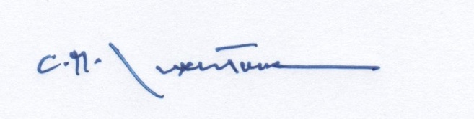
Charles Maxlow-Tomlinson BSc (Hons) MRICS
Consultant, Property Services

